CRUD MySQL
Create:
CREATE TABLE users (
id INT AUTO_INCREMENT PRIMARY KEY,
name VARCHAR(100),
email VARCHAR(100),
created_at TIMESTAMP DEFAULT CURRENT_TIMESTAMP
);
INSERT INTO users (name, email) VALUES ('John Doe', 'john@example.com');
Retrieve:
SELECT * FROM users WHERE id = 1;
Update:
UPDATE users
SET name = 'John Smith', email = 'johnsmith@example.com'
WHERE id = 1;
Delete:
DELETE FROM users WHERE id = 1;
MongoDB:
MongoDB is a NoSQL database, and CRUD operations are performed using its MongoDB query language, which is more document-centric (collections of JSON-like documents). Let's assume you have a users collection with documents like the following:
{
"_id": ObjectId("60d21b4667d0d8992e610c85"),
"name": "John Doe",
"email": "john@example.com",
"created_at": "2022-01-01T00:00:00Z"
}
Create:
db.users.insertOne({
name: 'John Doe',
email: 'john@example.com',
created_at: new Date()
});
db.users.insertMany([
{ name: 'John Smith', email: 'johnsmith@example.com', created_at: new Date() },
{ name: 'Jane Doe', email: 'jane@example.com', created_at: new Date() }
]);
Retrieve:
db.users.find();
db.users.findOne({ _id: ObjectId("60d21b4667d0d8992e610c85") });
db.users.find({ email: 'john@example.com' });
Update:
db.users.updateOne(
{ _id: ObjectId("60d21b4667d0d8992e610c85") },
{
$set: { name: 'John Smith', email: 'johnsmith@example.com' }
}
);
db.users.updateMany(
{ email: 'john@example.com' },
{ $set: { email: 'newemail@example.com' } }
);
Delete:
db.users.deleteOne({ _id: ObjectId("60d21b4667d0d8992e610c85") });
db.users.deleteMany({ email: 'john@example.com' });
Conclusion:
- MySQL is a relational database that uses SQL for CRUD operations. It works well with structured data, has fixed schemas, and supports ACID (Atomicity, Consistency, Isolation, Durability) transactions.
- MongoDB is a NoSQL database that uses a flexible document-based approach. It stores JSON-like documents, and CRUD operations are done with MongoDB's query language. MongoDB excels with large, unstructured data, horizontal scalability, and flexible schemas.
Depending on your application, you would choose MySQL for structured, relational data and MongoDB for unstructured, document-based data with the need for scalability and flexibility.

Postman Practice
Get Request
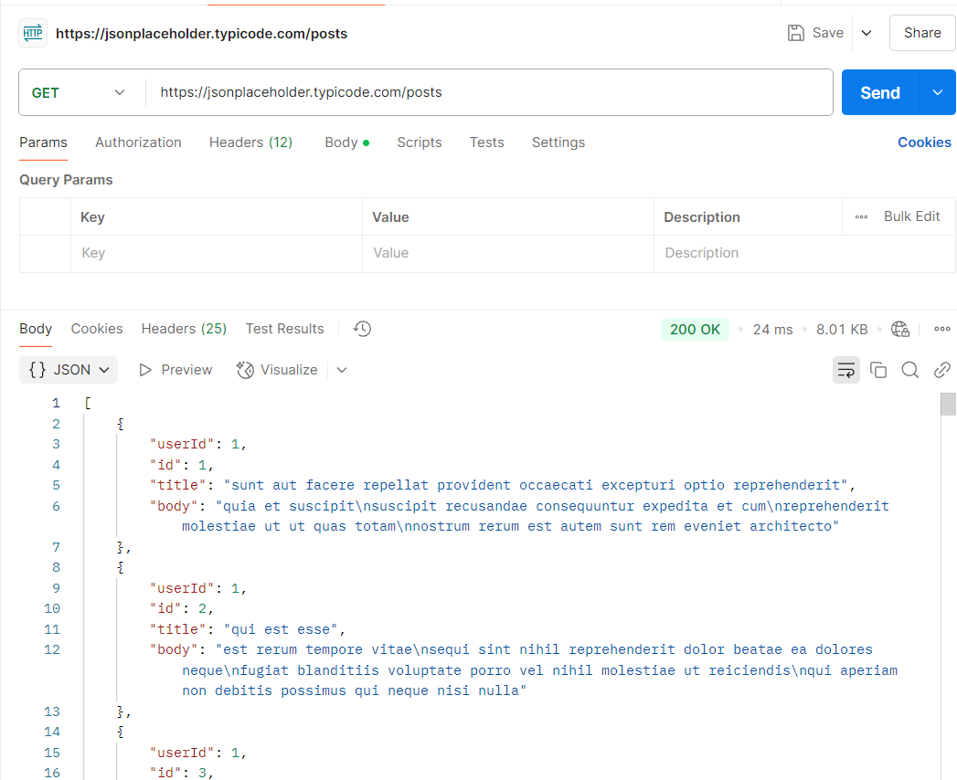
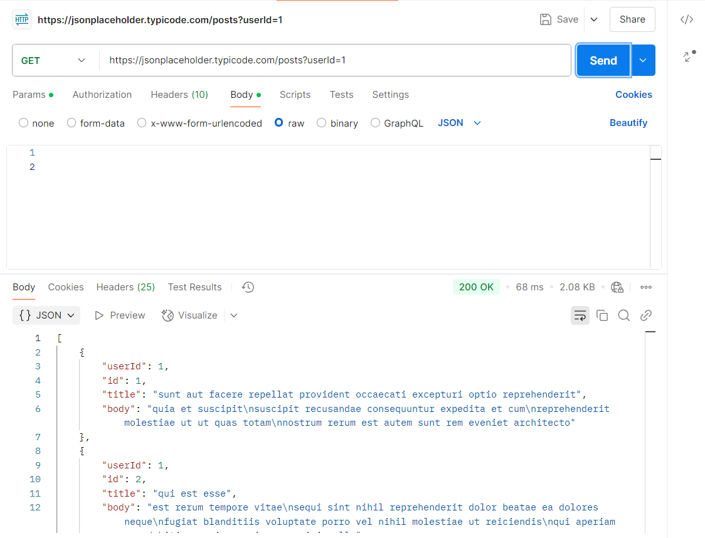
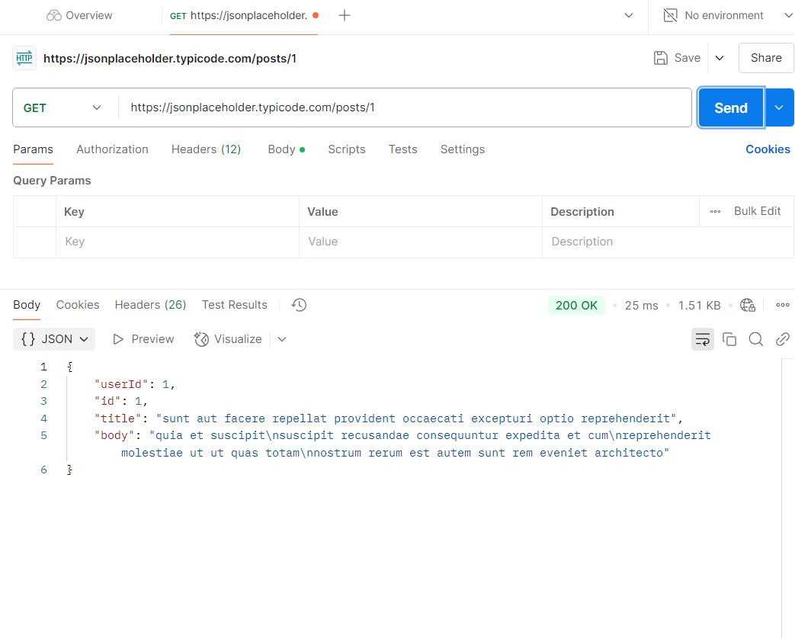
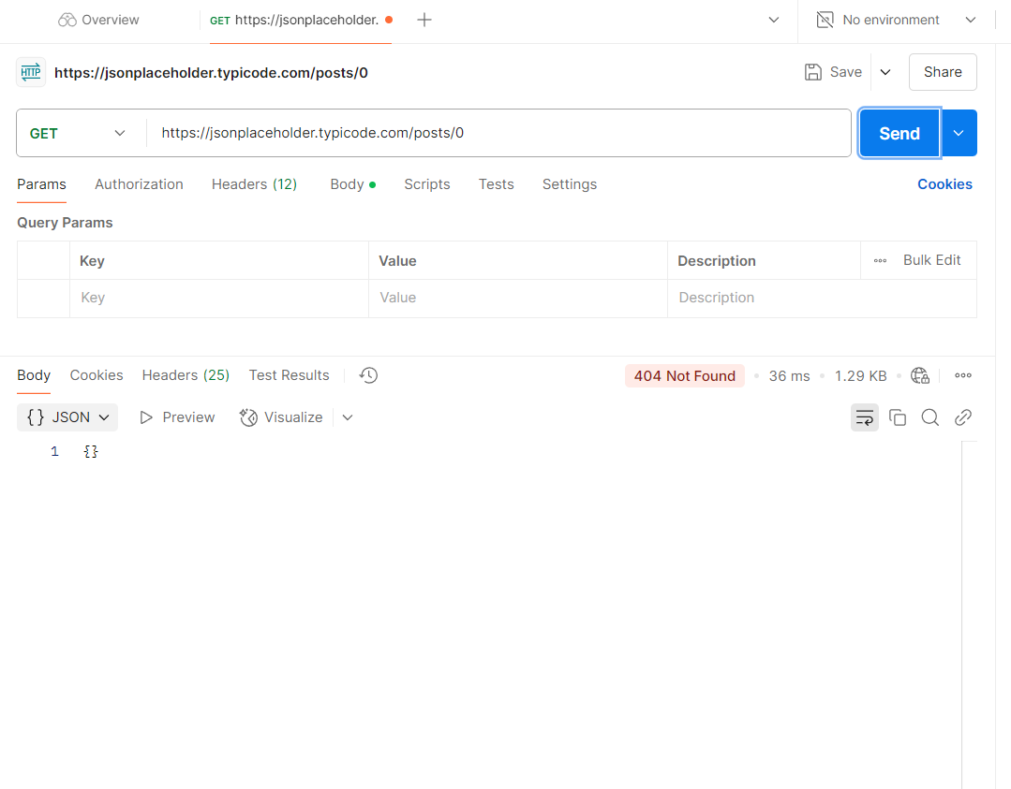
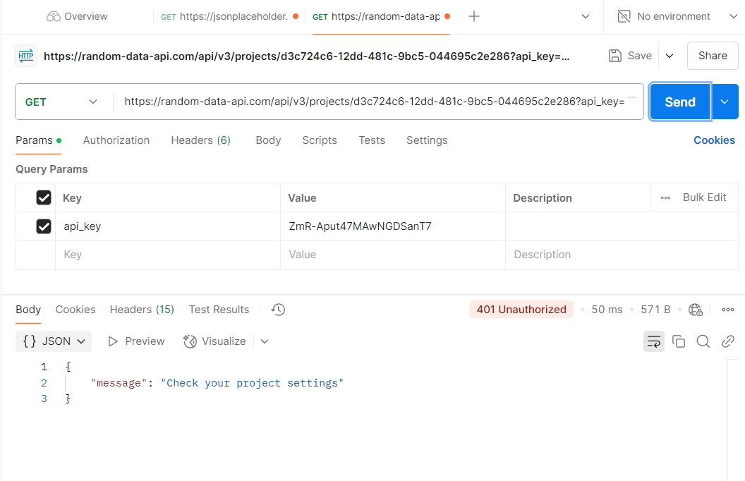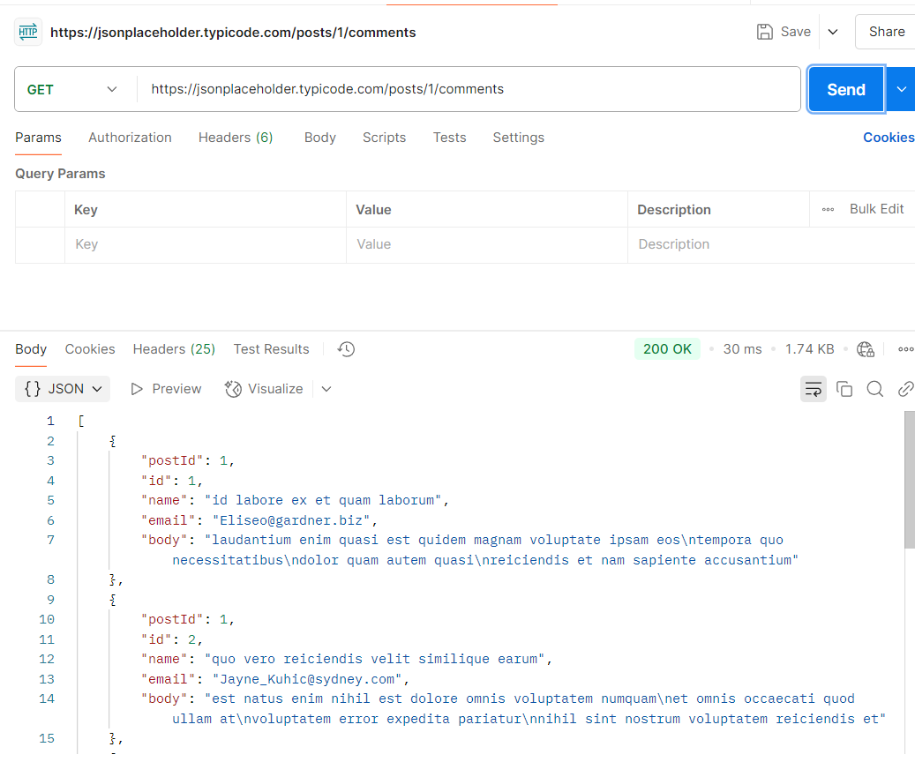
POST

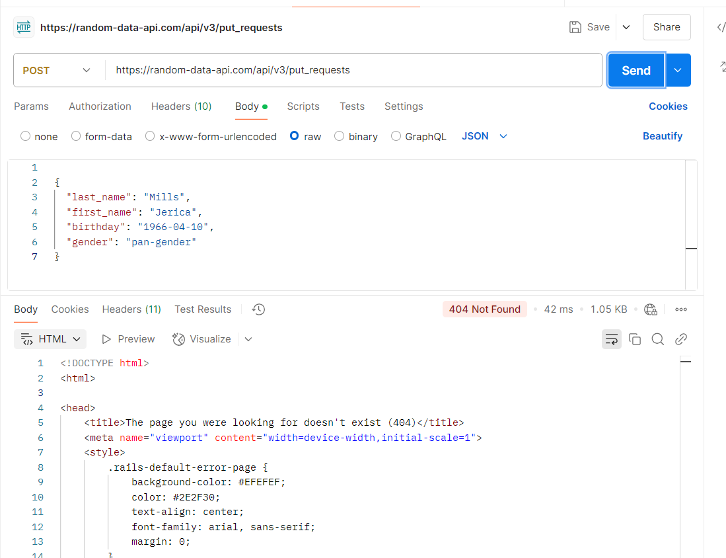

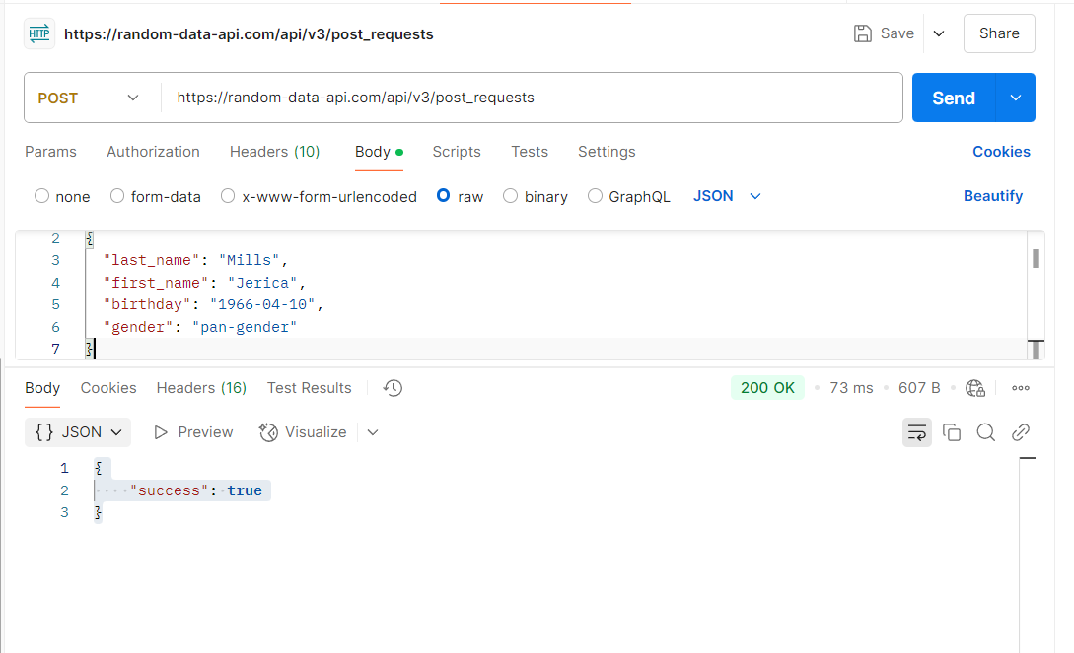
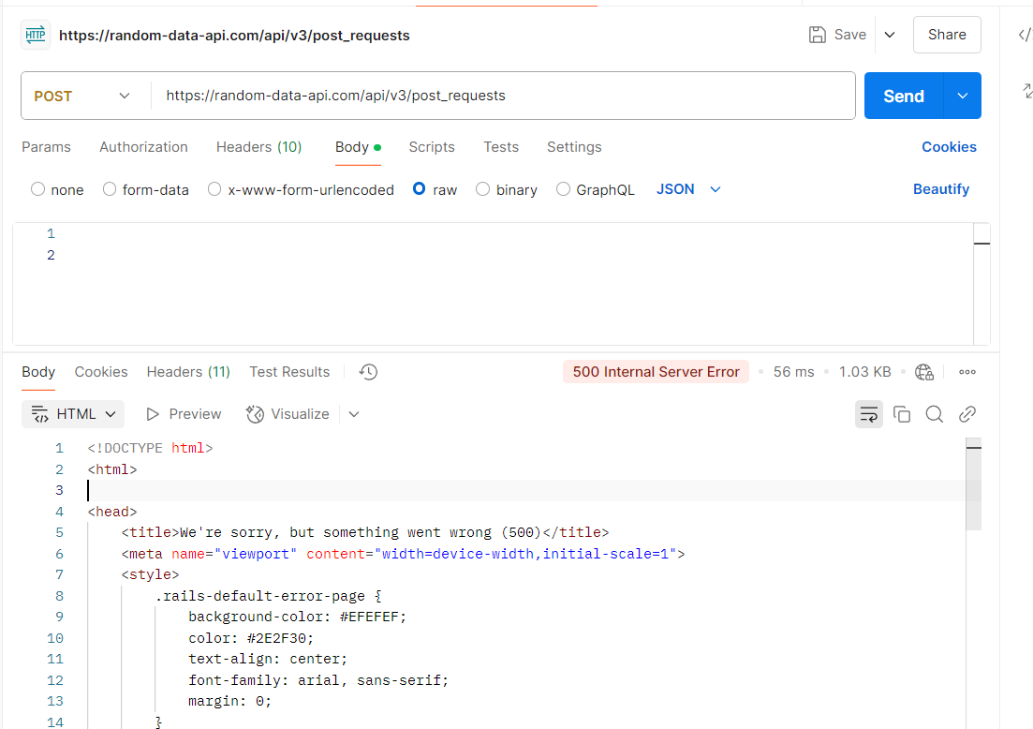
Patch
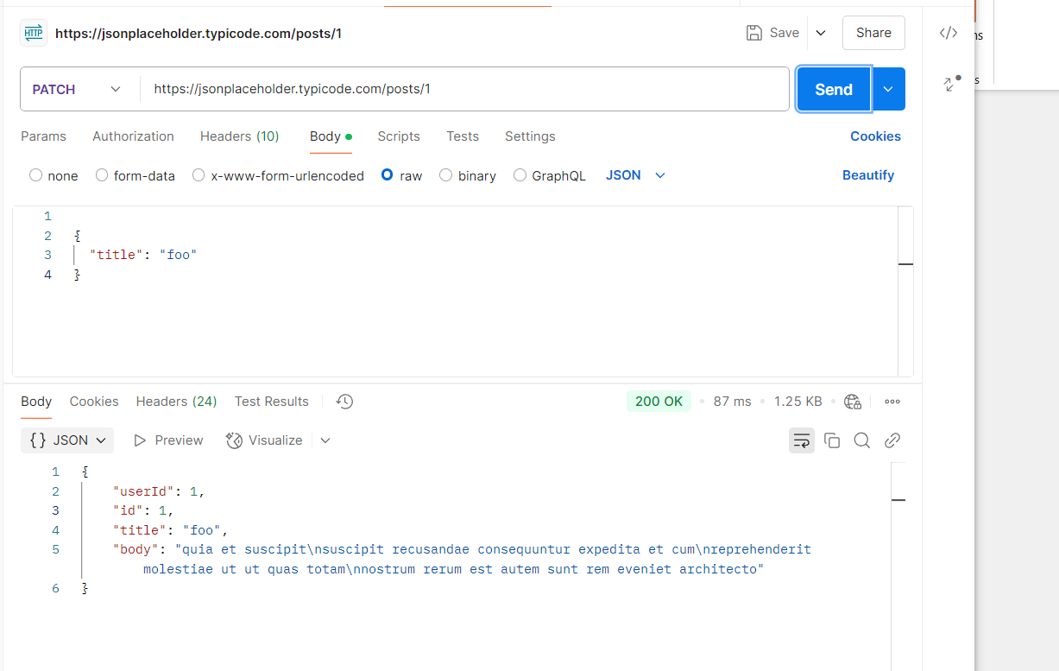
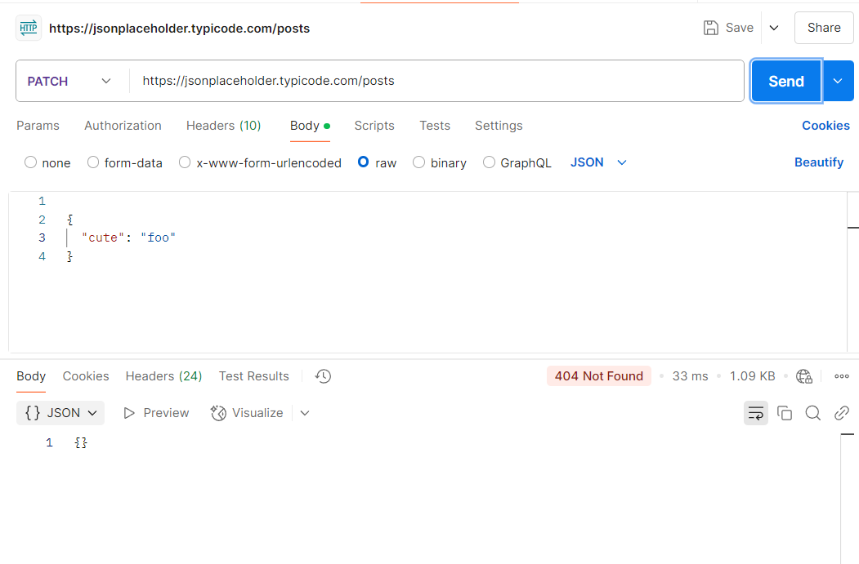
Delete
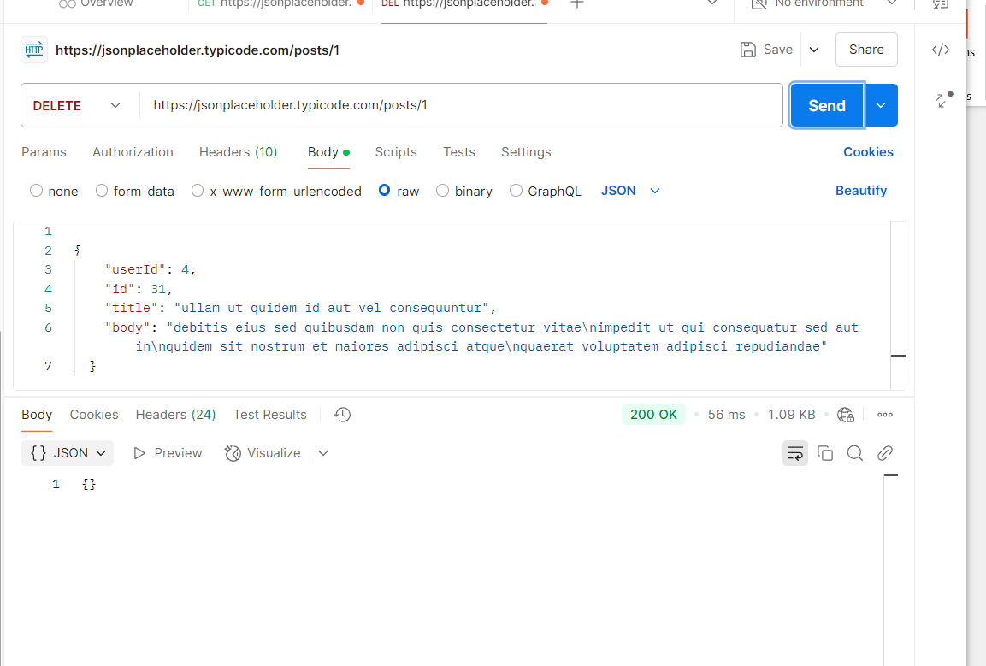
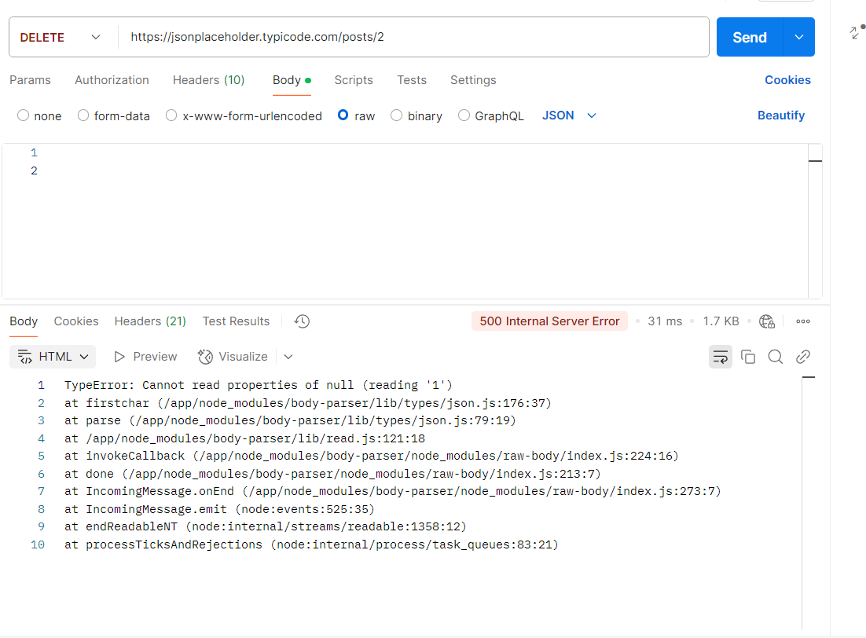
Put
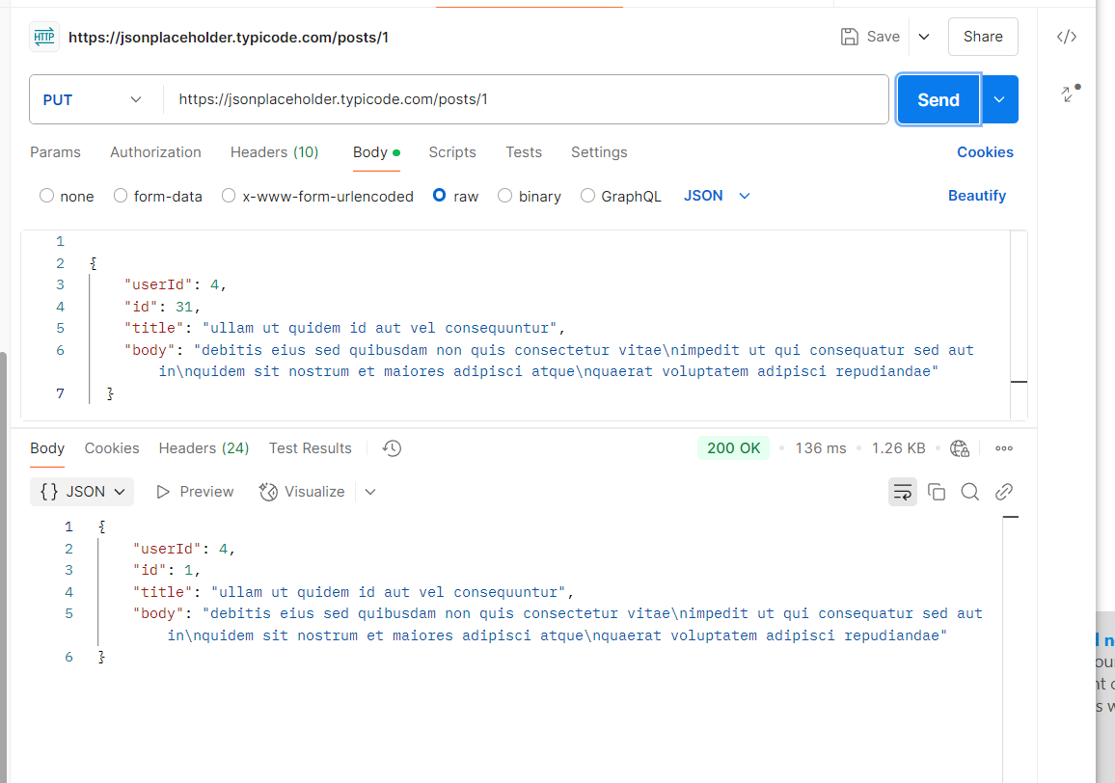
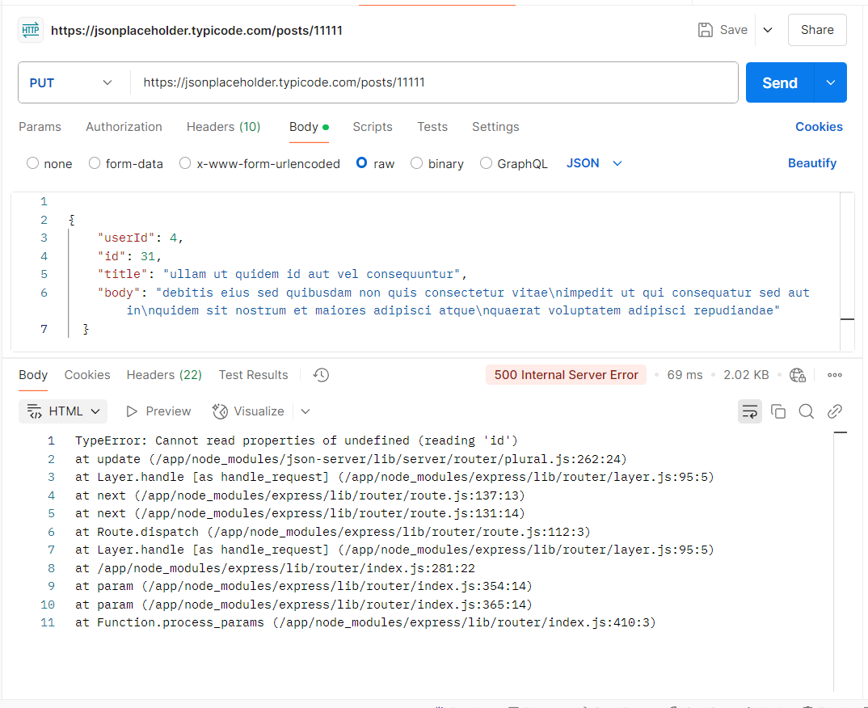
API Design
- Find the Customer's Payments (Credit Card 1, Credit Card 2, PayPal, Apple Pay)
GET /customers/{customerId}/payments
- Find the Customer's Order History Between 10/10/2022 and 10/24/2022
GET /customers/12345/orders?startDate=2022-10-10&endDate=2022-10-24
- Find the Customer's Delivery Addresses
GET /customers/{customerId}/delivery-addresses
- Get Customer's Default Payment and Default Delivery Address
GET /customers/{customerId}/defaults
- Find 2 Collection of APIs Example (e.g., Twitter, PayPal, YouTube) — Naming Convention
Twitter API:
- GET /users/{userId}/tweets - Fetch a user’s tweets.
- POST /users/{userId}/tweets - Create a new tweet.
- DELETE /users/{userId}/tweets/{tweetId} - Delete a specific tweet.
YouTube API:
- GET /videos/{videoId} - Retrieve details of a specific video.
- POST /videos - Upload a new video.
- DELETE /videos/{videoId} - Delete a specific video.
- Design a Collection of APIs for a Blog Website
6.1 Posts API
- GET /posts: Retrieve all blog posts.
- GET /posts/{postId}: Retrieve a specific blog post.
- POST /posts: Create a new blog post.
- PUT /posts/{postId}: Update an existing blog post.
- DELETE /posts/{postId}: Delete a blog post.
6.2 Comments API
- GET /posts/{postId}/comments: Retrieve all comments for a specific post.
- GET /comments/{commentId}: Retrieve a specific comment.
- POST /posts/{postId}/comments: Add a new comment to a post.
- PUT /comments/{commentId}: Update an existing comment.
- DELETE /comments/{commentId}: Delete a comment.
6.3 Users API
- GET /users/{userId}: Retrieve a specific user’s details.
- POST /users: Create a new user.
- PUT /users/{userId}: Update a user’s details.
- DELETE /users/{userId}: Delete a user.
Path Variables: You should use path variables for resources that are specific to an entity (e.g., /{customerId}, /{postId}, etc.).
Pluralization: Use plural names for collections of resources (e.g., /customers, /posts, /orders).
HTTP Methods:
- GET: Retrieve resources.
- POST: Create new resources.
- PUT: Update existing resources.
- DELETE: Delete resources.
This API design follows standard RESTful principles, which help to make the APIs clear, predictable, and easy to use.

